**Macintosh HD:Users:jackkoehler:Dropbox (Friends of Pathways):FOP Master Files:Communications:Logos - FOP:FOP_orangelogo_ƒ.eps**

**Youth Trail Crew Job with Friends of Pathways**

Come be part of a 5 member crew working on a number of projects on the Bridger-Teton National Forest this summer. As a crew member you will help complete a variety of manual tasks including restoration and maintenance of trails, new trail lay-out and construction, and the closure and rehab of old trails. The job requires teamwork, personal motivation, enthusiasm for new challenges, and an excitement to work outdoors! Learn about your ability, your passion, and your local trail network!

Youth Trail Crew is an official position with Friends of Pathways, a local non-profit that works closely with the Bridger-Teton National Forest to manage 130 miles of front-country trails on Snow King, Teton Pass, and Munger Mountain. To be considered for acceptance you must complete a written [application](https://friendsofpathways.org/wp-content/uploads/2018/04/2018-Youth-Trail-Crew-Application.doc) and attend a personal interview. Youth Trail Crew will earn an hourly wage beginning at $15.00/hour.

**Job Requirements**

* Be at least 15 and not more than 18 years of age by the job start date.
* Successfully complete the application and interview process.
* Be eager to work closely with the USFS Trail Crew on physically demanding projects on our public lands.
* Be able to commit to the full work schedule. Youth Trail Crew will work from June 14-August 12 on Monday through Thursday, 8:00 am – 4:30 pm.
* Demonstrate effective teamwork skills.
* No previous work experience is necessary but a positive attitude is essential.

**2020 Applications**

1. Apply by 5pm on May 14th.
2. If all application materials are received within the deadline you will be invited to a personal interview. Interviews will take place May 17-21. Email notification of interview appointments will be sent the week prior.
3. Candidates will be notified by May 24th.

**Apply Now!**

Visit the [Friends of Pathways Webpage](http://www.friendsofpathways.org/) and click on the About Us drop down menu and then the Jobs tab to [download an application](https://friendsofpathways.org/wp-content/uploads/2018/04/2018-Youth-Trail-Crew-Application.doc).

When completing your application, don't forget to complete all pages of the application and submit to [chris@friendsofpathways.org](mailto:chris@friendsofpathways.org) by May 14th.

**Interviews**

Once we have received all of the applications we will begin scheduling interviews for the week of May 17-21.  Interview times will be sent by email the week before. If you cannot make your scheduled appointment, contact us at least 24 hours in advance to reschedule.

**Selections**

All applicants who complete an application within set deadlines, including interview attendance, are eligible for hire. Applicants are prioritized based on application completeness, personal motivation and enthusiasm for the job, availability for job dates, previous team performance, and applicable experience. If you are unable to accept a position offered to you for some reason, please inform us promptly so that we may offer your place to someone who can.

Applicants will be notified of the status of their application by May 24th.

**Pay/Wages**

Youth Trail Crew members will earn a rate of $15.00/hour

All Friends of Pathways employees must have a social security number before they begin work.  Please file for a number if you do not already have one.

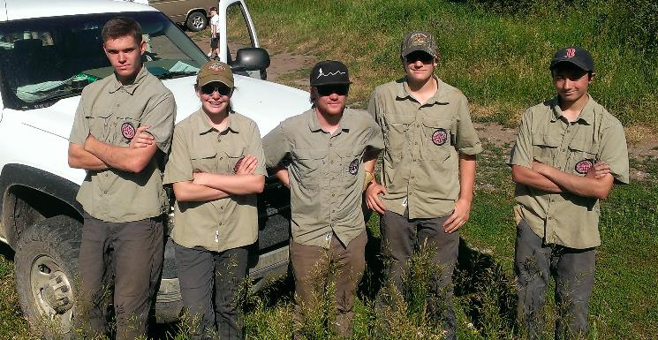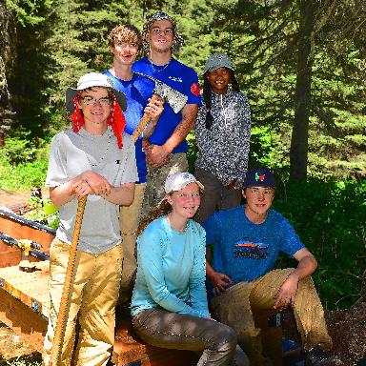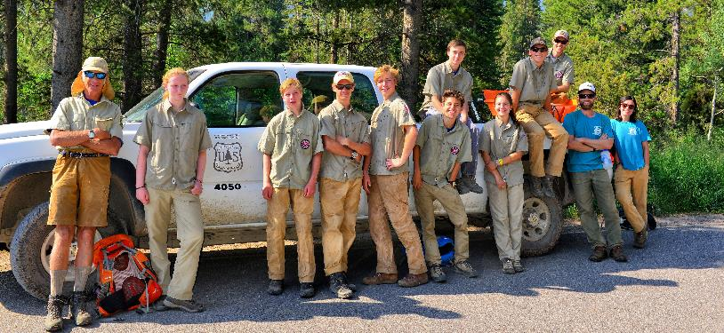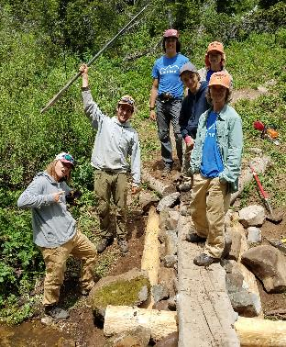

**Work Schedule**

Youth Trail Crew members are expected to arrive on time for work prepared for the day. The normal work schedule will be Monday through Thursday, 9 am - 5 pm.  There are two 15-minute breaks and a 30-minute lunch break during the day.  The first day of work is an orientation and safety training day. Members are also encouraged to come out for National Trails Day on June 5th to get a preview of the trail projects that we will be working on for the beginning of the season.

You must have a reliable way of getting to work each day. We will meet at the Friends of Pathways office at 20 E. Simpson Ave. at 9am each morning. From there we will provide transportation to the work site each day and back by 5pm each afternoon.

**Personal Equipment**

Trail Crew members work hard outdoors in a mountain climate all day and need to be prepared for a variety of conditions. You will need a few specific personal items to be comfortable and safe at work. It is also recommended that you purchase a good pair of leather work gloves and leather boots. Each member will have an Osprey Backpack provided for them to use for the summer and you will need to carry your lunch, water for the day, rain gear, and sunscreen. Sunglasses are recommended or safety glasses will be provided for use during your job.

* Pants - Carhartt or Mountain Khaki style work pants.
* Shirts – Cotton shirts are fine, long sleeve button up shirts work well too as they keep the bugs and sun off. We will also provide work t shirts for the crew.
* Boots – Leather hiking boots with Vibram soles and a rubber toe rand work well.
* Gloves – A tough leather work glove.
* Rain Gear – We are outside all day in the mountains and the weather is variable. Some sort of rain jacket and rain pant is a vital part of your kit.
* Layers - It is a good idea to bring an insulation layer every day (wool, polypro, fleece).
* Sun Protection – Sunscreen and a hat.
* Bug Spray – June is especially buggy in some areas of the forest.
* Water – During a full day of work you will need between 2-4 liters of water.
* Food – Bring snacks and lunch each day.