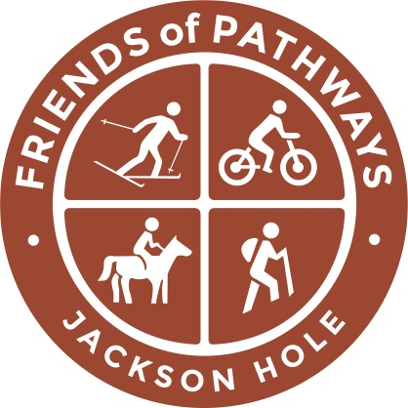
Youth Trail Crew Letter of Reference

Please email this letter of reference to chris@friendsofpathways.org no later than May 15th, 2019. You may provide your letter of reference to the applicant to send in with their application, or you may mail the recommendation separately. If the reference letter does not arrive or is not postmarked by the due date the applicant may be disqualified. To mail separately, send letter of reference to:

Youth Trail Crew Program
Friends of Pathways
PO Box 2062
20 E. Simpson Ave.
Jackson, WY 83001
307-733-4534

FOR (APPLICANT’S NAME):
Your Name:
Phone Number:
Mailing Address:
Email Address:

Please provide the following information:

1. What is your relationship to the applicant and how long have you known them?

2. What are the applicant’s greatest strengths?

3. Why do you feel this applicant would benefit from participating in this program?

4. How does the applicant work with others in a team setting?

Any Additional Comments?

